Tutorial – Drawing for Form and Store
Tai-Hu Huang
Ver. 1.0, 18th November, 2013
Jyun-Wei Chen
Ver. 2.0, 22th November, 2022
Contents
About This Document 1
Tutorial – Drawing for Form and Store 2
Step 1 Create Model Project 2
Step 2 Create Canvas Model and Adaptee 2
Step 3 Modify the Setting of Startup Project 5
Step 4 Compile Model 6
Step 5 Create View in Windows Form 6
Step 6 Add Model in Views 7
Step 7 Create Canvas Model and Adaptor in DrawingForm 8
Step 8 Create View in DrawingForm 9
Step 9 Execute DrawingForm 13
Step 10 Create View in Windows App 14
Step 11 Create Canvas Model and Adaptor in DrawingApp 14
Step 12 Create View in DrawingApp 16
Step 13 Execute DrawingApp 21

About This Document
在本次的練習中，將會練習到如何使用同一個Model來建置兩種不同View (Windows Form與 Windows Store APP)的繪圖程式。
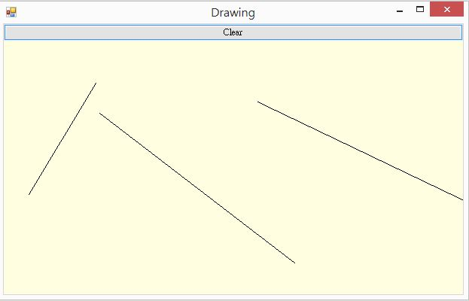
Figure 1 程式執行結果 - Windows Form
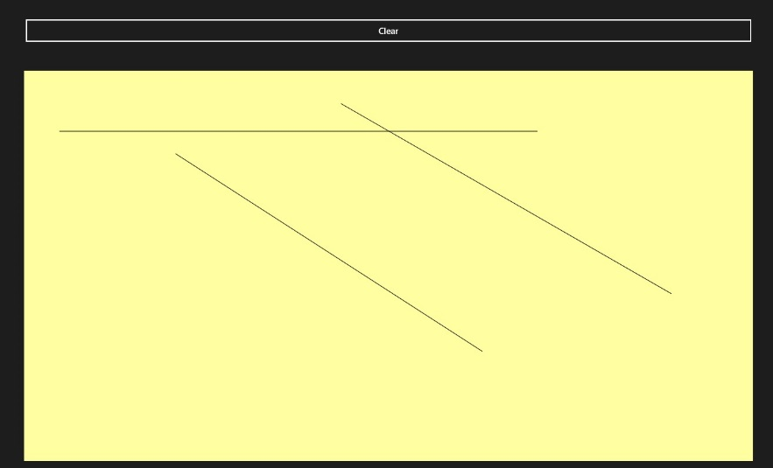
Figure 2 程式執行結果 - Windows Store APP

Tutorial – Drawing for Form and Store
- Create Model Project
打開Visual Studio 2019 Community後，點選 檔案 > 新增 > 專案 > 搜尋 ”類別庫” > 選擇 “類別庫(.NET Framework) ”，然後輸入專案名稱“DrawingModel”，即可成功建立一個空白的C#專案，此為用來放置Model的專案。

Figure 3 建立類別庫專案

- Create Canvas Model and Adaptee
刪除掉原本系統自己建立的Class1.cs，於“DrawingModel”中新增三個Class，如下：
- IGraphics.cs
namespace DrawingModel
{
interface IGraphics
{
void ClearAll();
void DrawLine(double x1, double y1, double x2, double y2);
}
}

- Line.cs
namespace DrawingModel
{
class Line
{
public double x1;
public double y1;
public double x2;
public double y2;

public void Draw(IGraphics graphics)
{
graphics.DrawLine(x1, y1, x2, y2);
}
}
}

- Model.cs
using System.Collections.Generic;

namespace DrawingModel
{
class Model
{
public event ModelChangedEventHandler _modelChanged;
public delegate void ModelChangedEventHandler();
double _firstPointX;
double _firstPointY;
bool _isPressed = false;
List<Line> _lines = new List<Line>();
Line _hint = new Line();

public void PointerPressed(double x, double y)
{
if (x > 0 && y > 0)
{
_firstPointX = x;
_firstPointY = y;
_hint.x1 = _firstPointX;
_hint.y1 = _firstPointY;
_isPressed = true;
}
}

public void PointerMoved(double x, double y)
{
if (_isPressed)
{
_hint.x2 = x;
_hint.y2 = y;
NotifyModelChanged();
}
}

public void PointerReleased(double x, double y)
{
if (_isPressed)
{
_isPressed = false;
Line hint = new Line();
hint.x1 = _firstPointX;
hint.y1 = _firstPointY;
hint.x2 = x;
hint.y2 = y;
_lines.Add(hint);
NotifyModelChanged();
}
}

public void Clear()
{
_isPressed = false;
_lines.Clear();
NotifyModelChanged();
}

public void Draw(IGraphics graphics)
{
graphics.ClearAll();
foreach (Line aLine in _lines)
aLine.Draw(graphics);
if (_isPressed)
_hint.Draw(graphics);
}

void NotifyModelChanged()
{
if (_modelChanged != null)
_modelChanged();
}
}
}

- Modify the Setting of Startup Project
當你需要執行多個專案(在這個Lab中，你將會建立三個專案)，又不想要一直切換Setup Project時，可以於Solution內設定，對著Solution點擊右鍵，點擊Properties，並選擇Current selection，如此，當你點擊某一特定專案時，即會執行該專案。
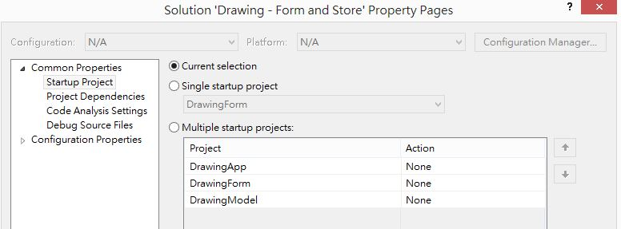
Figure 4 Right Click > Properties > Current selection

- Compile Model
- 於“DrawingModel”專案點擊右鍵，選擇建置(Build)。
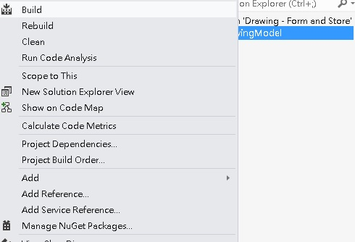
Figure 5 Build

- 於“DrawingModel”專案點擊右鍵，選擇在檔案總管中開啟資料夾(Open Folder in File Explorer)。
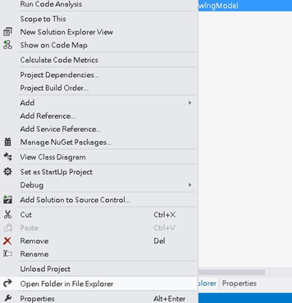
Figure 6 Open Folder in File Explorer

- 開啟資料夾後，在bin > Debug可以找到一個.dll檔。這個檔案即為上述三個Class編譯後的檔案。
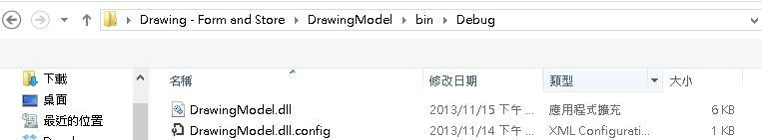
Figure 7 bin > Debug > DrawingModel.dll

- Create View in Windows Form
新增一個Windows Form專案命名為“DrawingForm”。
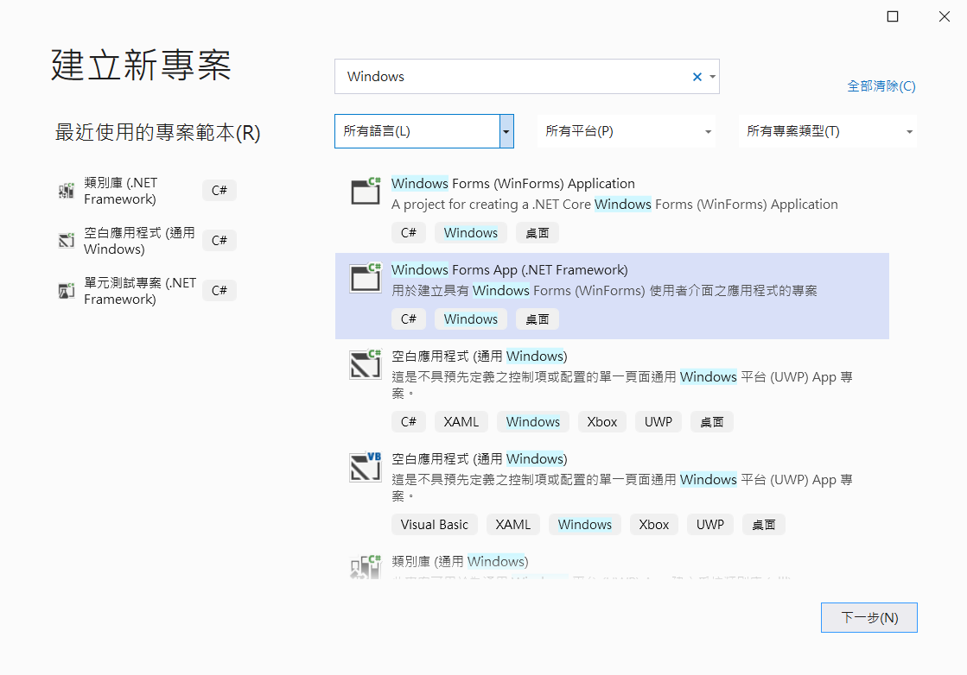
Figure 8 檔案 > 新增 > 專案 > Windows Forms App (.NET Framework)

- Add Model in Views
於“DrawingForm”專案執行下述之步驟。下列步驟，目的是讓目前的View可以擁有不同Project的檔案之Link，而非擁有一個實體檔案。
- 對著專案點擊右鍵加入一個新資料夾，命名為“Model”
- 對著資料夾“Model”點擊右鍵，選擇加入現有項目(注意：要選擇“加入做為連結(Add As Link)”)，選擇於“DrawingModel”內的三個.cs檔
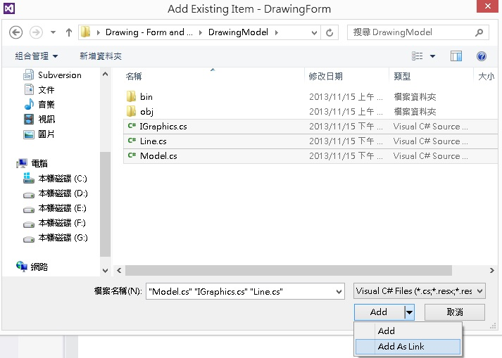

- Create Canvas Model and Adaptor in DrawingForm
於“DrawingForm”專案加入下列檔案。
- 對著專案點擊右鍵加入一個新資料夾，命名為“PresentationModel”
- 對著資料夾“PresentationModel”點擊右鍵，選擇加入新類別

  - WindowsFormsGraphicsAdaptor.cs
using System.Windows.Forms;
using System.Drawing;
using DrawingModel;

namespace DrawingForm.PresentationModel
{
class WindowsFormsGraphicsAdaptor : IGraphics
{
Graphics _graphics;

public WindowsFormsGraphicsAdaptor(Graphics graphics)
{
this._graphics = graphics;
}

public void ClearAll()
{
// OnPaint時會自動清除畫面，因此不需實作
}

public void DrawLine(double x1, double y1, double x2, double y2)
{
_graphics.DrawLine(Pens.Black, (float) x1, (float) y1, (float) x2, (float) y2);
}
}
}

  - PresentationModel.cs
using DrawingModel;
using System.Windows.Forms;

namespace DrawingForm.PresentationModel
{
class PresentationModel
{
Model _model;
public PresentationModel(Model model, Control canvas)
{
this._model = model;
}

public void Draw(System.Drawing.Graphics graphics)
{
// graphics物件是Paint事件帶進來的，只能在當次Paint使用
// 而Adaptor又直接使用graphics，這樣DoubleBuffer才能正確運作
// 因此，Adaptor不能重複使用，每次都要重新new
_model.Draw(new WindowsFormsGraphicsAdaptor(graphics));
}
}
}

- Create View in DrawingForm
並於“DrawingForm”專案新增一個Component Class，命名為“DoubleBufferedPanel”
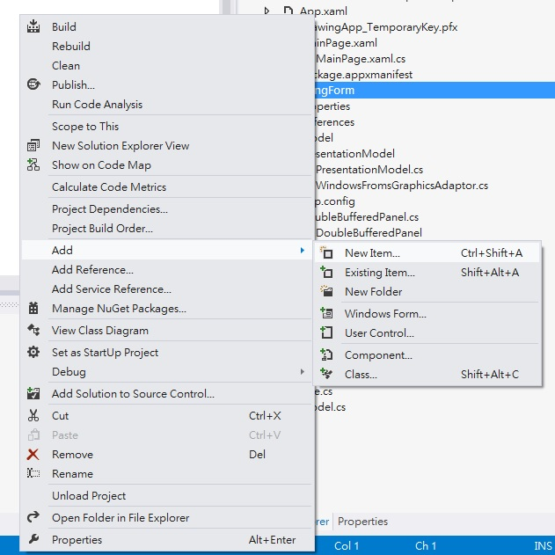
Figure 9 Add > New Item

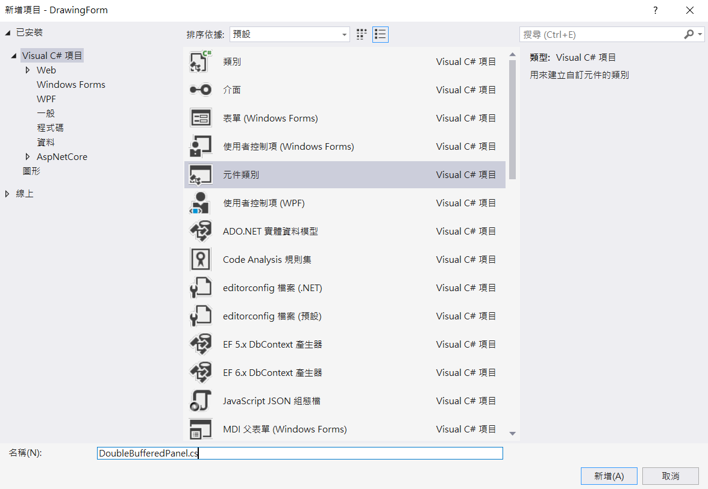
Figure 10 Component Class
將DoubleBufferedPanel.cs展開後，刪除掉Component1.Designer.cs，並點擊DoubleBufferedPanel加入以下程式碼。

using System.Windows.Forms;

namespace DrawingForm
{
class DoubleBufferedPanel : Panel
{
public DoubleBufferedPanel()
{
DoubleBuffered = true;
}
}
}

於“DrawingForm”專案點選Form1.cs展開後的Form1，並加入以下程式碼，黃底部分，為我們所撰寫的程式碼。

using System;
using System.Collections.Generic;
using System.ComponentModel;
using System.Data;
using System.Drawing;
using System.Linq;
using System.Text;
using System.Threading.Tasks;
using System.Windows.Forms;

namespace DrawingForm
{
public partial class Form1 : Form
{
DrawingModel.Model _model;
PresentationModel.PresentationModel _presentationModel;
Panel _canvas = new DoubleBufferedPanel();

public Form1()
{
InitializeComponent();
//
// prepare canvas
//
_canvas.Dock = DockStyle.Fill;
_canvas.BackColor = System.Drawing.Color.LightYellow;
_canvas.MouseDown += HandleCanvasPressed;
_canvas.MouseUp += HandleCanvasReleased;
_canvas.MouseMove += HandleCanvasMoved;
_canvas.Paint += HandleCanvasPaint;
Controls.Add(_canvas);
//
// prepare clear button
//
Button clear = new Button();
clear.Text = "Clear";
clear.Dock = DockStyle.Top;
clear.AutoSize = true;
clear.AutoSizeMode = System.Windows.Forms.AutoSizeMode.GrowAndShrink;
clear.Click += HandleClearButtonClick;
Controls.Add(clear);
//
// prepare presentation model and model
//
_model = new DrawingModel.Model();
_presentationModel = new PresentationModel.PresentationModel(_model, _canvas);
_model._modelChanged += HandleModelChanged;
}

public void HandleClearButtonClick(object sender, System.EventArgs e)
{
_model.Clear();
}

public void HandleCanvasPressed(object sender, System.Windows.Forms.MouseEventArgs e)
{
_model.PointerPressed(e.X, e.Y);
}

public void HandleCanvasReleased(object sender, System.Windows.Forms.MouseEventArgs e)
{
_model.PointerReleased(e.X, e.Y);
}

public void HandleCanvasMoved(object sender, System.Windows.Forms.MouseEventArgs e)
{
_model.PointerMoved(e.X, e.Y);
}

public void HandleCanvasPaint(object sender, System.Windows.Forms.PaintEventArgs e)
{
_presentationModel.Draw(e.Graphics);
}

public void HandleModelChanged()
{
Invalidate(true);
}
}
}

- Execute DrawingForm
執行DrawingForm專案，你將可以看到Form的執行結果。於此階段，你已經完成了第一個View，接下來你會需要第三個專案來製作Windows Store App的View。
Figure 11 Execute DrawingForm

- Create View in Windows App
新增一個Windows Store App專案命名為“DrawingApp”。並且參照Step 6，將Model的連結加入至該專案
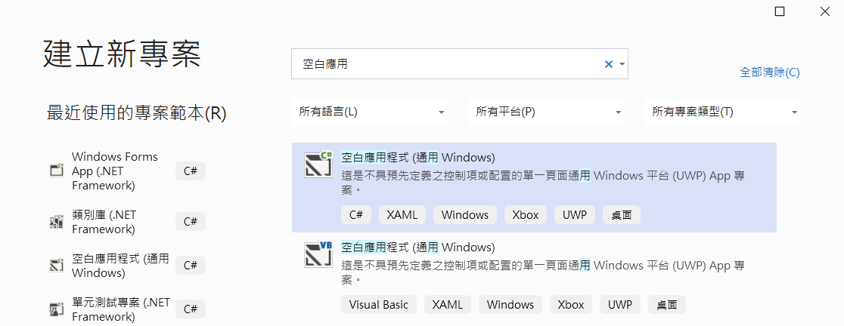
Figure 12-1 檔案 > 新增 > 專案 > 空白應用程式 (通用Windoes)

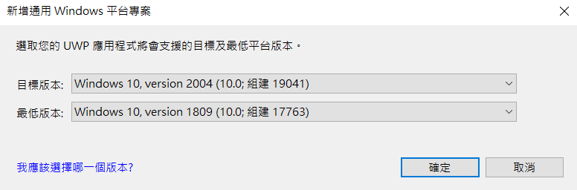
Figure 13-2 使用預設的UWP版本

- Create Canvas Model and Adaptor in DrawingApp
於“DrawingApp”專案加入下列檔案。
- 對著專案點擊右鍵加入一個新資料夾，命名為“PresentationModel”
- 對著資料夾“PresentationModel”點擊右鍵，選擇加入新類別

  - WindowsStoreGraphicsAdaptor.cs
由於Windows Store和Windows Form繪圖所使用的介面不相同，故需要使用Adaptor來做轉接。繼承的是IGraphics，故一定會有ClearAll與DrawLine兩個介面，但介面實作的Code則依照不同的需求來決定。
using Windows.UI;
using Windows.UI.Xaml.Controls;
using Windows.UI.Xaml.Shapes;
using Windows.UI.Xaml.Media;
using DrawingModel;

namespace DrawingApp.PresentationModel
{
class WindowsStoreGraphicsAdaptor : IGraphics
{
Canvas _canvas;

public WindowsStoreGraphicsAdaptor(Canvas canvas)
{
this._canvas = canvas;
}

public void ClearAll()
{
_canvas.Children.Clear();
}

public void DrawLine(double x1, double y1, double x2, double y2)
{
Windows.UI.Xaml.Shapes.Line line = new Windows.UI.Xaml.Shapes.Line();
line.X1 = x1;
line.Y1 = y1;
line.X2 = x2;
line.Y2 = y2;
line.Stroke = new SolidColorBrush(Colors.Black);
_canvas.Children.Add(line);
}
}
}

  - PresentationModel.cs
using System;
using System.Collections.Generic;
using System.Linq;
using System.Text;
using System.Threading.Tasks;
using Windows.UI.Xaml.Controls;
using DrawingModel;

namespace DrawingApp.PresentationModel
{
class PresentationModel
{
Model _model;
IGraphics _igraphics;

public PresentationModel(Model model, Canvas canvas)
{
this._model = model;
_igraphics = new WindowsStoreGraphicsAdaptor(canvas);
}

public void Draw()
{
// 重複使用igraphics物件
_model.Draw(_igraphics);
}
}
}

- Create View in DrawingApp
於“DrawingApp”專案點選MainPage.xaml，初始畫面為一個空白的視窗，你可以將需要的元件使用拖拉的方式放置上來。
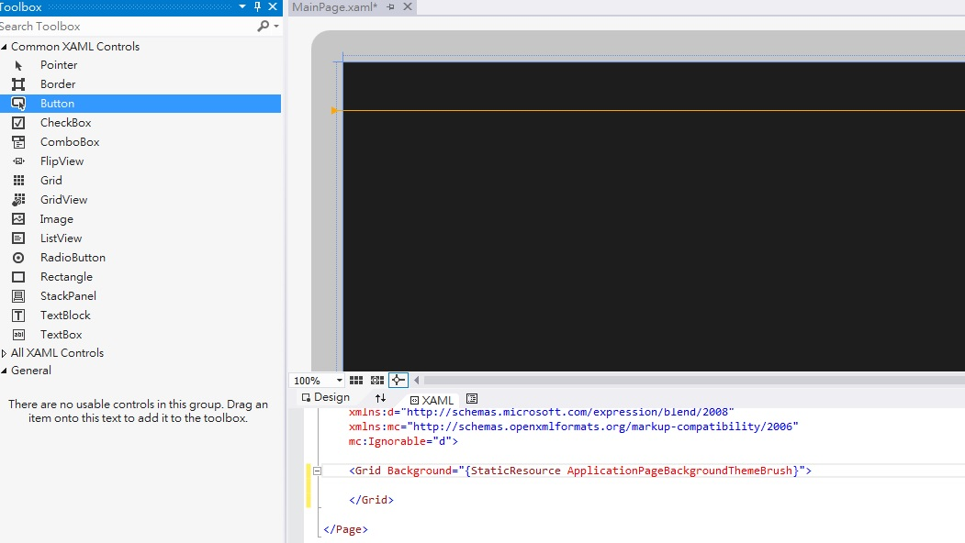
Figure 14 Initial Designer

於此App，你會需要一個Button與一個Canvas
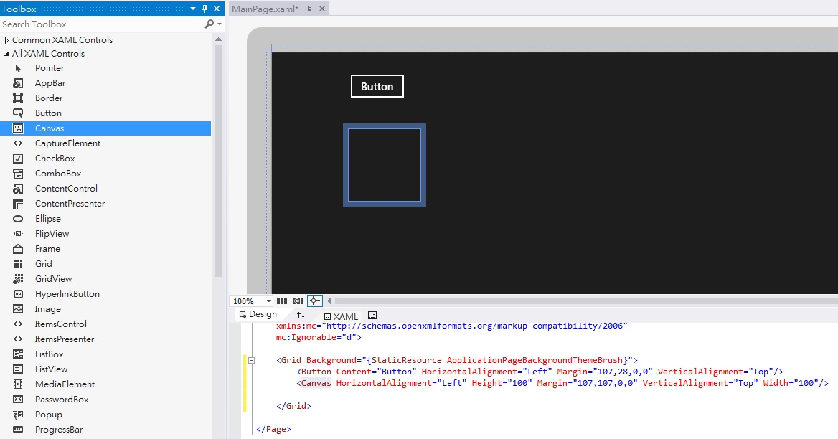
Figure 15 App Contains a Button and a Canvas

當你需要修改元件屬性時，你可以使用Properties視窗進行設定，當然，你也可以直接修改XML。於此App中，你需要將Button顯示的文字修改成“Clear”，為了讓Button可以保持在最上面，故需要將Vertical Alignment設定成“Top”，由於只有一個Button所以我們希望可以將其占滿整個空間，故需要設定HorizontalAlignment為“Stretch”。為了美觀考量，可以修改Margin，讓元件與元件或元件與整個程式的視窗保持一定的距離。最後，請務必記得，一定要修改該元件的命名。
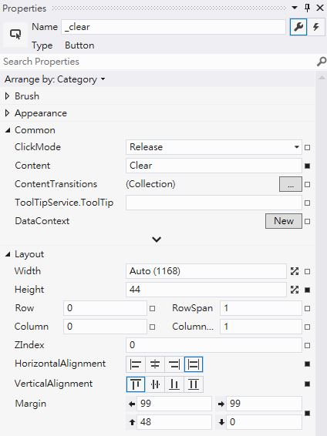
Figure 16 Properties of the Button
由於預設Canvas背景顏色與App顏色相同，故我們希望可以將Canvas換成另一種顏色，並且透過修改Margin，讓Canvas可以擴展到最大。
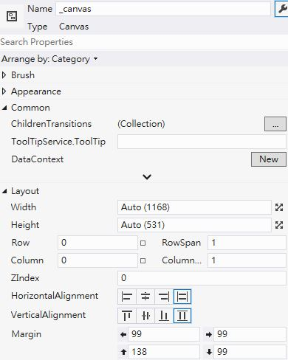
Figure 17 Properties of Canvas

最後產生出來的XML如下(建議同學可以透過Designer自行設計，惟x:Name須相同)：
<Page
x:Class="DrawingApp.MainPage"
xmlns="http://schemas.microsoft.com/winfx/2006/xaml/presentation"
xmlns:x="http://schemas.microsoft.com/winfx/2006/xaml"
xmlns:local="using:DrawingApp"
xmlns:d="http://schemas.microsoft.com/expression/blend/2008"
xmlns:mc="http://schemas.openxmlformats.org/markup-compatibility/2006"
mc:Ignorable="d">
<Grid Background="{StaticResource ApplicationPageBackgroundThemeBrush}">
<Button x:Name="_clear" Content="Clear" HorizontalAlignment="Stretch" Height="44" Margin="99,48,99,0" VerticalAlignment="Top"/>
<Canvas x:Name="_canvas" Margin="99,138,99,99" Background="#FFFFFFA0"/>
</Grid>
</Page>

然後開啟MainPage.xaml.cs檔案(將在Solution Explorer的MainPage.xaml展開即可看到)，並且加入以下程式碼，黃底部分，為我們所撰寫的程式碼。

using System;
using System.Collections.Generic;
using System.IO;
using System.Linq;
using Windows.Foundation;
using Windows.Foundation.Collections;
using Windows.UI.Xaml;
using Windows.UI.Xaml.Controls;
using Windows.UI.Xaml.Controls.Primitives;
using Windows.UI.Xaml.Data;
using Windows.UI.Xaml.Input;
using Windows.UI.Xaml.Media;
using Windows.UI.Xaml.Navigation;

// The Blank Page item template is documented at http://go.microsoft.com/fwlink/?LinkId=234238

namespace DrawingApp
{
/// <summary>
/// An empty page that can be used on its own or navigated to within a Frame.
/// </summary>
public sealed partial class MainPage : Page
{
DrawingModel.Model _model;
PresentationModel.PresentationModel _presentationModel;

public MainPage()
{
this.InitializeComponent();
_model = new DrawingModel.Model();
_presentationModel = new PresentationModel.PresentationModel(_model, _canvas);
_canvas.PointerPressed += HandleCanvasPressed;
_canvas.PointerReleased += HandleCanvasReleased;
_canvas.PointerMoved += HandleCanvasMoved;
_clear.Click += HandleClearButtonClick;
_model._modelChanged += HandleModelChanged;
}

/// <summary>
/// Invoked when this page is about to be displayed in a Frame.
/// </summary>
/// <param name="e">Event data that describes how this page was reached. The Parameter
/// property is typically used to configure the page.</param>
protected override void OnNavigatedTo(NavigationEventArgs e)
{
}

private void HandleClearButtonClick(object sender, RoutedEventArgs e)
{
_model.Clear();
}

public void HandleCanvasPressed(object sender, PointerRoutedEventArgs e)
{
_model.PointerPressed(e.GetCurrentPoint(_canvas).Position.X, e.GetCurrentPoint(_canvas).Position.Y);
}

public void HandleCanvasReleased(object sender, PointerRoutedEventArgs e)
{
_model.PointerReleased(e.GetCurrentPoint(_canvas).Position.X, e.GetCurrentPoint(_canvas).Position.Y);
}

public void HandleCanvasMoved(object sender, PointerRoutedEventArgs e)
{
_model.PointerMoved(e.GetCurrentPoint(_canvas).Position.X, e.GetCurrentPoint(_canvas).Position.Y);
}

public void HandleModelChanged()
{
_presentationModel.Draw();
}
}
}

- Execute DrawingApp
執行DrawingApp專案，你將可以看到App的執行結果。

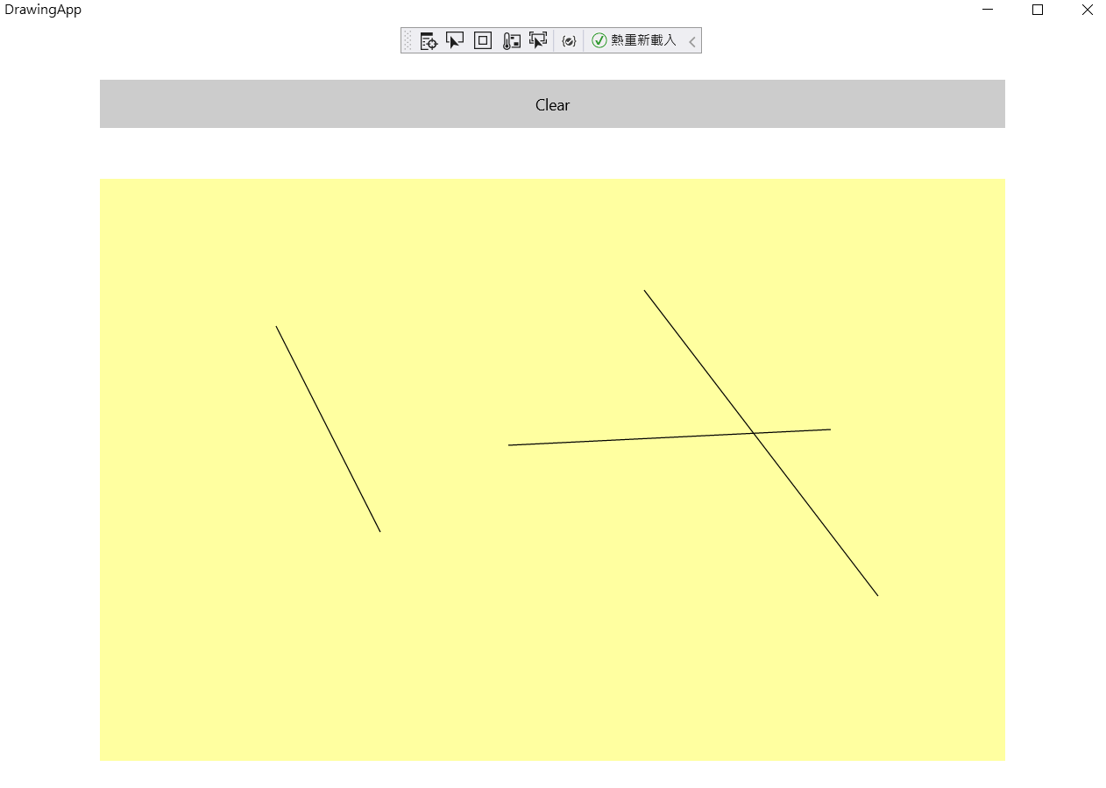
Figure 17 執行結果

- The End -

